TEAM EARTH
Pradnya P. Jadhav
(Head of Marketing Department)
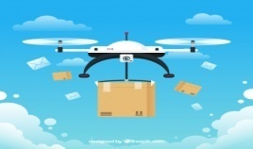
Marketing Plan
AIRWAYS
We give Wings to Your Package
Case Understanding:
Our Company Airway Delivery is a courier company which has branches across India and delivers to most pin codes. The Company’s Board has decided to venture into ‘Hyper Local Delivery space’ and want to conduct local delivery through drones. As a rule, all flying objects in India, needs to take permission from (DGCA) Director General of Civil Aviation. Trials are conducted at beyond the visual line of sight and successful test deliveries are conducted. Company has decided to start this venture as “Short Range Drone Based Services” instead of “Long Range Drone Flight operations due to high purchase cost of Long range drones. Company Intend to build an end to end Drone Operations & Management Platform through which a rapid scaling of business can be achieved. Company has performed several successful beta Testing deliveries for initial participants such as food delivery companies, few Pharma Chains & Internal Local Deliveries and looking forward to exploring more business areas for cost-effective cargo deliveries

BCS Solution
As, it is new technical start-up relatively new idea it will measurably require marketing strategies.
As companies objective within a year is to establish these new brand
Steps to be taken –
- Working on 4Ps of Marketing
- Market Observation
- Collaboration & Mergers

Product: Our Company is about courier and the product that company has decided to venture is “Hyper Local Delivery Space” and wants to conduct local delivery through Drones.
Place: Local Areas
Promotion:

Pricing Strategy:

Category of Couriers | Courier weight | Price
A | 0.1 grams to 500 grams | Rs. 60
B | 501 grams to 1kg | Rs. 80
C | From 1.01kg to 5kg | Rs. 100/kg
D | 5.01kg to 10kg | Rs. 110/kg

Targeting Customer Strategy
- To venture into Hyper Local Delivery Space

- Conduct local delivery through Drones

- Starting Venture with short range Drone based services

- We should to know about what items customers would likely to purchase and have delivered by drone that product market should be focused for delivery drone. Products like health care delivery, food delivery etc.
Marketing a Drone Photography/ Videography Business
Marketing Strategy to reach to the customer
Drone advertisements, depending on local law, can fly almost anywhere. Potential customers at the park or in an office building are now directly reachable, making drone advertising its own platform full of potential to engage the public.
Drones are also considered the future of last-mile delivery for consumer goods since it would reduce cost per delivery and delivery time.
The advantages of drone delivery:
- Drone delivery can improve logistics efficiency. The direct distance between two points is the closest.
- Drone delivery can save logistics costs.
- Drone delivery promotes the economy of underdeveloped areas.
Exhibition of Drones
- Drone International Expo is a platform to connect with wide array of buyers & industries.
- Also the best way to connect with customers and industrial people.
Future Prospect about Exhibition
Contributing with NexGen Exhibition Pvt Ltd. Asia for leading & outstanding exhibition organizing company in Asia with innovative projects conceptualized & executed with its in depth knowledge information & understanding of business beyond borders.
NexGen Exhibition is led by a team of professionals & delivered successful projects at India, Thailand, Vietnam, Bangladesh, Kenya, Uganda, Sri Lanka etc.

Target Market
The targeting markets are:
- Amazon
- Wal-Mart
- Dominos
Services provided by US to convince consumers to shop online more:
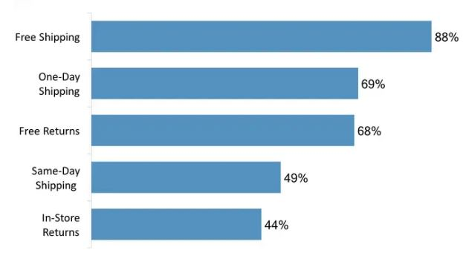

As shown in the above graph we can observe the services provided by US in percentage.
Comparing to the US market services provided by our company:
- Free Shipping at every weekend, festivals, seasons, and free shipping onwards Rs300
- Same Day shipping on urgent basis whenever required
- Online Exchange

Conclusion
As, drone services is more convenient & fastest mode of deliveries. Every Marketing strategy which is been used will help to create the ecosystem to develop our company and create large scale of consumer base.
From overall marketing plan it can be conclude that no need of additional communication channel between vehicle and operator or server and this is more secured, due to the line-of-sight connection.

